**SMART BACKUP:**

As the technology of mobile is changing day by day and people love to use new interface of the mobile e.g. Android, Iphone, BlackBerry Etc.

But there are problem arises when we change, lost our phone or for somehow phone may be reset, that are:

1. Lossing our Important Contacts Number

2. Missing the Calendar Memo or reminder

3. Loosing the important Document

4. Important Emails

Here I have the solution for this type of problem with the smart tool called Smart Back Up.

The Smart Back Up tool which work to overcome the problem of loosing Contact, Calender, Document and Email from our Smart Phone.

Here we are using the Google APIs, REST and JSON Technology to sync all this with the user Gmail Account.

Here Interface may Look Like:

**Login Page Application Interface**

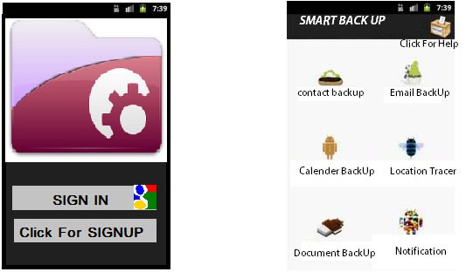

Right Now I am Working for this App on Android Platform.

**How the Application Will Work:**

**Login And Signup:** For Each individual we will have their Gmail account. User can use their existing email account or create a new account which user can user to maintain their Backup.

The Gmail Public Labels API

Which allow authenticating the user for the application.

Execptions: Internet Connection Check and Gmail Account Password.

2. BackUps:

The Google API allows manipulation of Entry implementing the Account

There are API available which we will use to maintain the backup of the data.

Responsibilities:

**1. Contact Backup:** This is responsible to upload the contacts available on the user phone to the user account and when the user needed that contact back to phone user just needed to click on sync and the contact will automatically download on the user phone or the use can view the contacts in his gmail account as well.

**2. Email Backup**: This is simple imap and pop3 properties of the gmail which we use to retrieve the pervious or new emails of the use and here user can also sync their existing mails which are on the phone to the account as well.

**3.Calender Back:** This is use to sync the entries in the use calendar like Memo, Reminder etc in the phone to Google calendar api.When user click on calendar sync it will automatically sync the user calendar with the Google calendar API.

**4: Document Backup:** This is use to sync the document which available on the phone and can be access to Google document api via Google cloud.

**5:Location Tracer**: This is use to keep the record of the location of the phone after a time which is assign by the user this we keep the records of where the cell phone was and is.It keep sync user location with Google MAP api and keep the record of the locations of the user with data and time.

**6: Notification:** This is an option thing which we can use for any notification e.g. Updates, Message.

**Things Which Done Yet:**

Google Account Access is working fine.

I am almost done with Google contact sync and it is working I can sync my phone no by entering the phone no from phone and updating the Google account.

And very soon it will keep working with saved contact no on the phone.

**Here I need your suggestion on few portions:**

**1.** How to create interactive Interface for the App.

**2.** How to deal with Google Api to Store the User Location Coordinates on the Gmail account and get the coordinates on the map when needed.

**3.** What is the thing should be included in Notification.

**4.** Is there any necessarily to keep the records of the user who use this application.

(HARPREET SINGH)